EXPERIMENT 1
Convert Image to Grayscale
SOURCE CODE :
import cv2
img=cv2.imread(r"C:\Users\Amrita\Desktop\image\Screenshot 2026-09-30 143819.png")
gray = cv2.cvtColor(img, cv2.COLOR_BGR2GRAY)
cv2.imshow("Original Image", img)
cv2.imshow("Gray Image", gray)
cv2.waitKey(0)
cv2.destroyAllWindows()
Output
- Original color image
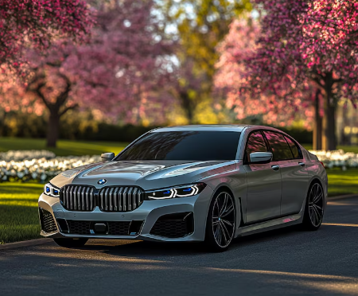
- Grayscale image
